**CERTIFICATE**

OF PARTICIPATION

The following is awarded to

{Name}

For successfully participating in **Introduction to Scratch Learning Program** (January’23 – March’23) on **Meraki E-Learning Platform**.

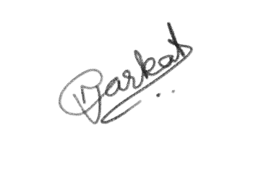

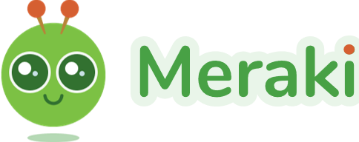 ***Nidhi Anarkat  
CEO & Co-Founder***